ULTRAVIOLET (UV) SAFETY AWARENESS
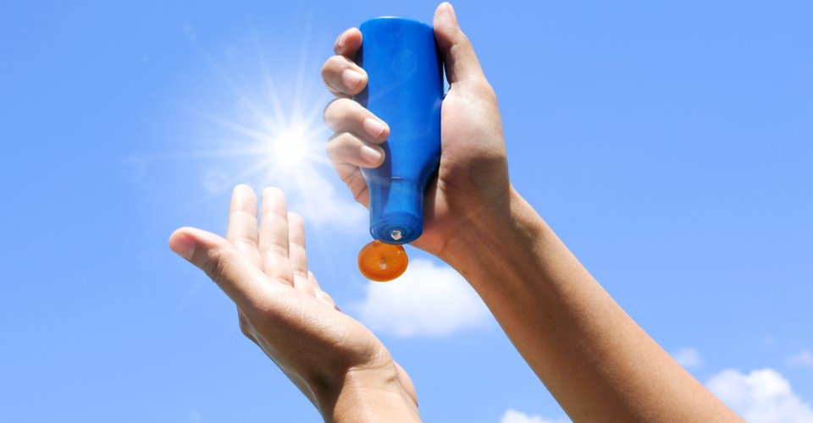
During summer months, families spend a great deal of time outdoors soaking up the sunshine. But we often overlook the risks associated with sun exposure.
Unprotected sun exposure can lead to premature skin aging, vision issues and skin cancer. And it only takes 15 minutes for the sun’s ultraviolet (UV) rays to begin causing damage to your skin.
July is UV Safety Awareness Month, giving each of us a great opportunity to spread the word about the importance of protecting your skin from the harmful effects of UV rays.
WHAT YOU NEED TO KNOW ABOUT UV RADIATION
The sun emits radiation called UV-A and UV-B rays. Both of which can damage your skin and eyes.
UV-B rays have shorter wavelengths that reach the outer layer of your skin and can cause sunburns. While UV-A rays have longer wavelengths that are capable of penetrating the middle layer of your skin.
UV radiation is at its highest when the sun’s rays are the strongest – which is typically in the timeframe from late morning to mid-afternoon, during summer months, and at high altitudes.
Exposure to both UV-A and UV-B rays are associated with the development of skin cancer. And exposure can come from both the sun and artificial sources like tanning beds.
Skin cancer is the most common type of cancer in the U.S. According to the Centers for Disease Control and Prevention (CDC), nearly 5 million people are treated for skin cancer each year.
While some people may be at a higher risk (e.g. individuals with a family or personal history of skin cancer), the most preventable cause of skin cancer is overexposure to UV light.
HOW TO STAY SAFE IN THE SUN
Damage from exposure to UV rays builds up over time, so it’s important to begin sun protection practices from an early age.
Follow these sun safety tips:
- Put on sunscreen. Apply a broad-spectrum sunscreen with an SPF factor of 15 or higher at least 15 minutes before going outside. Even if it’s cloudy or a cool day. Reapply sunscreen at least every two hours. And after swimming or sweating.
- Find shade. Use the shade (e.g. umbrella or tree) to take periodic breaks from the sun.
- Wear protective clothing. You can now find SPF clothing. Or wear long sleeves and pants when practical. Protect your head, face and neck by wearing a wide brim hat.
- Protect your eyes with sunglasses. Wrap-around sunglasses provide the best protection by blocking UV rays from all sides.
- Discourage indoor and outdoor tanning. Speak with your preteens and teens about the risks of UV exposure and long-term consequences.
TREATING SUNBURNS
A sunburn is a type of thermal burn that can vary in its severity. It may take a couple of days for the severity of the sunburn to become evident.
Sunburn treatment focuses on treating the symptoms by reducing pain, swelling and discomfort.
As with other minor burns, start by rinsing your sunburn with cool water for at least 20 minutes or until the pain is relieved. Or use a cool, clean compress if water isn’t available. Continue to cool the skin several times a day.
Additionally, you may find further relief by taking an over-the-counter pain reliever or applying a moisturizer, lotion or gel.
As the sunburn begins to heal, avoid peeling away the damaged skin. Do not pop intact blisters as this can increase your chances for infection. You should also take steps to protect your skin from further sun exposure while it heals.
If the sunburn is more severe or if the area begins to show signs of infection, seek medical care.

